**Instructions to perform test executions using Selenium Grid and recording video on Node Machine**



Contents

1. Overview 3

2. Introduction 3

2.1 When to use Grid 3

2.2 What is Hub? 3

2.3 What is Node? 3

3. Launching Hub 4

3.1 Prerequisites for launching hub: 4

3.2 Using command Prompt: 4

3.3 In Selenium Framework: 4

4. Launching Node 4

4.1 Prerequisites for launching node: 4

4.2 Using command Prompt: 5

4.3 In SeleniumFramework 7

5. Video Recording feature on Node Machine 7

5.1 Prerequisites 7

5.2 Commands to launch Hub for video recording 8

5.3 Commands to launch node for video recording 8

6. Run Scripts in SeleniumJava framework 9

# Overview

This document provides information about how to perform Test executions using Selenium Grid and explains how to record the video of the scripts that are distributed to different machines

# Introduction

Selenium Grid uses Hub-Node concept that specializes on running multiple tests across **different browsers, operating systems, and machines in parallel.**

# When to use Grid

Selenium Grid is used in the following scenarios:

* **Run your scripts against different browsers, operating systems, and machines all at the same time**. This will ensure that the application you are testing is fully compatible with a wide range of browser-OS combinations
* **Save time in execution of your test suites**. If you set up Selenium Grid to run, say ,4 tests at a time, then you would be able to finish the whole suite around 4 times faster.

# What is Hub?

* The Hub is the central point where you load your tests.
* There should be only one hub in a Grid.
* The machine containing the Hub is where the tests will be run, but you will see the browser being automated on the node.

# What is Node?

* Nodes are the Selenium instances that will execute the tests that you loaded on the hub.
* There can be one or more nodes in a Grid.
* Nodes can be launched on multiple machines with different platforms and browsers.
* The machines running the nodes need not be same platform as that of Hub.

# Launching Hub

# Prerequisites for launching hub:

* Make sure Java is installed on machine
* Selenium server standalone jar

# Launching Hub using command Prompt:

1. Open *Command Prompt*and go the root of the jar file you placed.

2. Type java *–jar selenium-server-standalone-2.46.0.jar –role hub* and hit ENTER.

3. Hub will be launched successfully similar to the below:

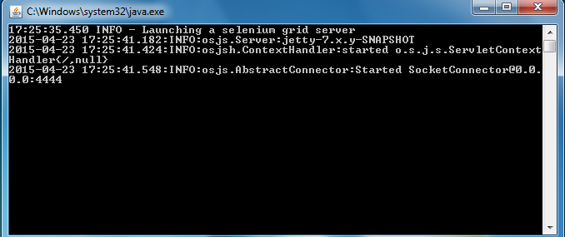

# Launching Hub in Selenium Framework:

* Go to config files->Hubconfig.json
* In HubConfig.json file, give port=”port number on which you want to launch hub”
* Go to Executables->Grid->Cmd_setUp->SetupHub.bat. Run setupHub.batch file, hub will be launched successfully as shown above

# Launching Node

# Prerequisites for launching node:

* Make sure Java is installed on machine
* Selenium server standalone jar
* Chrome Driver & IE Driver if scripts are to be executed on Chrome and IE browsers

# Launching Node using command Prompt:

Go to Machine where you want launch node

* Launch *command prompt* there and navigate to the root of the selenium server standalone jar file

**Launching a Firefox node:** If you wish to run test on a Firefox browser then type as below

* Type ***java –jar selenium-server-standalone-2.46.0.jar –role node***

***–hub http://*** ***[***IP address of hub***]/grid/register***

***–browser browserName=”firefox, maxInstances=3,version=30,***

***Platform=windows” –port [***Any free port***]***

Where,

browserName= Firefox(the browser you want to run your tests)

maxInstances= the no. of instances

* Node will be launched successfully as below

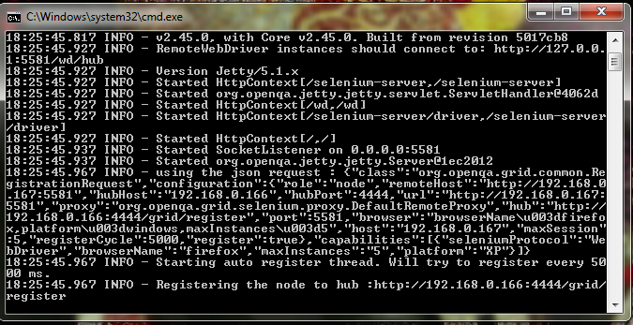

* Verify whether node is configured to hub or not. Open browser and go to <http://localhost:4444/grid/console>. you will see similar to this

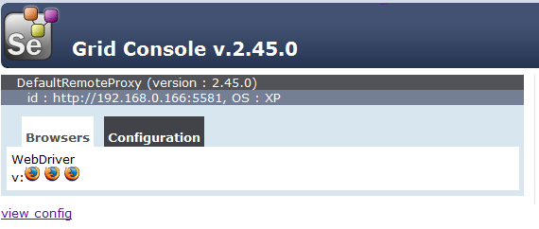

**Launching a Chrome node:** If you wish to run test on chrome browser then chrome driver.exe should be available on node machine and type as below

* Type ***java –jar selenium-server-standalone-2.46.0.jar -Dwebdriver.chrome.driver=path of chromedriver****[ C:\Users\Admin\Desktop\batch\chromedriver.exe****] –role node***

***–hub http:// [****IP address of Hub****]/grid/register –browser browserName=”chrome,maxInstances=3,version=42,***

***Platform=windows” –port*** [Any free port]

Where,

browserName= chrome(the browser you want to run your tests)

maxInstances= the no. of instances

Dwebdriver.chrome.driver=path of the chrome driver

* Verify whether node is configured to hub or not. Open browser and go to <http://localhost:4444/grid/console>. you will see similar to this

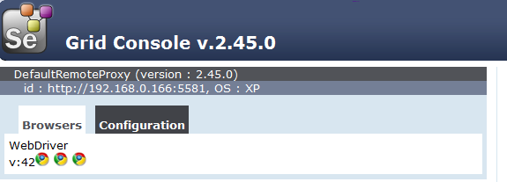

**Launching a Internet Explorer node:** If you wish to run test on a Internet Explorer browser then IEDriverserver.exe should be available on node machine type as below

* Type ***java –jar selenium-server-standalone-2.46.0.jar -Dwebdriver.ie.driver=[****path of Iedriver****] –role node –hub http:// [****IP address of Hub****]/grid/register –browser browserName=”internet explorer, maxInstances=3,version=30,Platform=windows”***

***–port***  [Any free port]

Where,

browserName= internet explorer(the browser you want to run your tests)

maxInstances= the no. of instances

Dwebdriver.ie.driver= path of the Internet explorer driver

* Verify whether node is configured to hub or not. Open browser and go to <http://localhost:4444/grid/console>. you will see similar to this

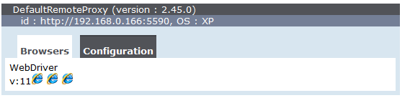

# Launching node in Selenium Framework

* Go to Config files->Nodeconfig.json
* In NodeConfig.json file, give

Port=”Any free port of node”

hubhost=”Url of hub”

hubport=”Port of hub”

* Go to Executables->Grid->Cmd_Setup->SetupNode.bat. Run setupNode.batch file, Node will be launched successfully.

# Video Recording feature on Node Machine

# Prerequisites

* Java
* Selenium server standalone jar
* Selenium video node jar

# Commands to launch Hub for video recording

**Using Command prompt:**

* Launch *command prompt* and navigate to the root of the selenium server standalone jar and selenium video node jar files are placed
* Type ***java -cp selenium-video-node-1.9.jar;selenium-server-standalone-2.46.0.jar org.openqa.grid.selenium.GridLauncher -servlets com.aimmac23.hub.servlet.HubVideoDownloadServlet -role hub***
* Hub will be launched successfully similar to the below:

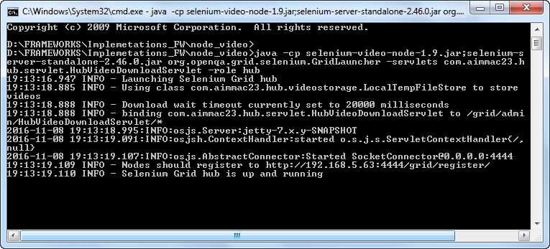

**In SeleniumJava Framework**

* Go to config files->Hubconfig.json
* In hubConfig.json file, give port=”port number on which you want to launch hub”
* Go to Executables->Grid->Cmd_setUp->SetupHubVideo.bat. Run SetupHubVideo.batch file, hub will be launched successfully as shown above

# Commands to launch node for video recording

**Using Command prompt:**

* Launch *command prompt* there and navigate to the root of the selenium server standalone jar and selenium video node jar files are placed
* Type ***java -cp selenium-video-node-1.9.jar;selenium-server-standalone-2.46.0.jar org.openqa.grid.selenium.GridLauncher -servlets com.aimmac23.node.servlet.VideoRecordingControlServlet -proxy com.aimmac23.hub.proxy.VideoProxy -role node -hub http://[ip adress of hub]/grid/register -Dwebdriver.chrome.driver=[Chromedriver path]***
* Node will be launched successfully similar to the below:

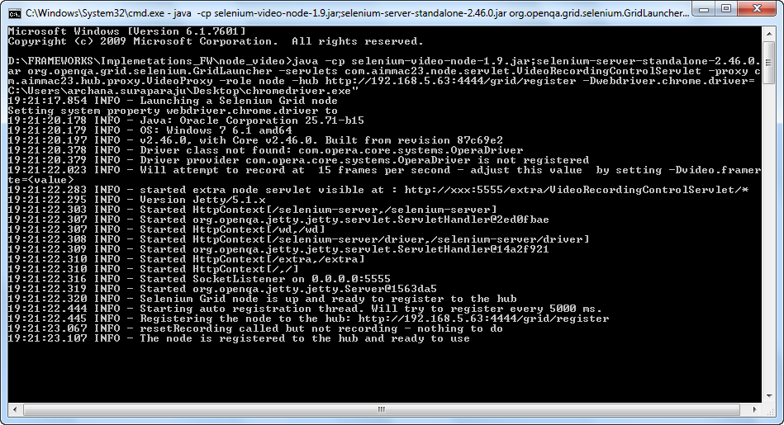

**In SeleniumJava Framework**

* Go to config files->Nodeconfig.json
* In NodeConfig.json file, give

Port=”Any free port of node”

hubhost=”Url of hub”

hubport=”Port of hub”

* Go to Executables->Grid->Cmd_Setup->SetupNodeVideo.bat. Run SetupNodeVideo.batch file, Node will be launched successfully as shown above

# Run Scripts in Selenium Java framework

Step 1: Write a test case in ***com.testsuite***

Step 2: Open ***ConfigFiles folder->sys.properties*** and do the following changes:

***ModeOfExecution=***Remote

***RemoteVideo=***false for SetupNode.batch

***RemoteVideo=***true for SetupNodeVideo.batch

***Cloud.Host.URL=***url of hub

Step 3: Run ***setupHub.batch*** file or ***SetupHubVideo.batch*** file(for node video recording feature)

Step 4:Run ***SetupNode.batch*** file or ***SetupNodeVideo.batch*** file

Step 5: Execute from ***testNg.xml*** file or Run Scripts through AntBatch file